Project Design Phase-II
Data Flow Diagram & User Stories

Date | 31 October 2026
Team ID | NA
Project Name | Electric Vehicle Market Performance & Insights
Maximum Marks | 4 Marks

Data Flow Diagrams:
A Data Flow Diagram (DFD) is a traditional visual representation of the information flows within a system. A neat and clear DFD can depict the right amount of the system requirement graphically. It shows how data enters and leaves the system, what changes the information, and where data is stored.
DFD Symbol Legend
Symbol | Name | Description
Oval / Rounded  shape | External Entity | A person, organization, or system outside the project that sends or receives data (e.g., Customer, Payment Gateway).
Rectangle with  numbered header | Process | An activity that transforms incoming data into outgoing data (e.g., Validate Request, Process Order).
Rectangle (solid fill, no number) | Data Store | A place where data is held for later use (e.g., Customer Database, Inventory).
Labeled arrow | Data Flow | The movement of data between entities, processes, and data stores, labeled with what data is being passed.

Data Flow Diagram (Level 1):
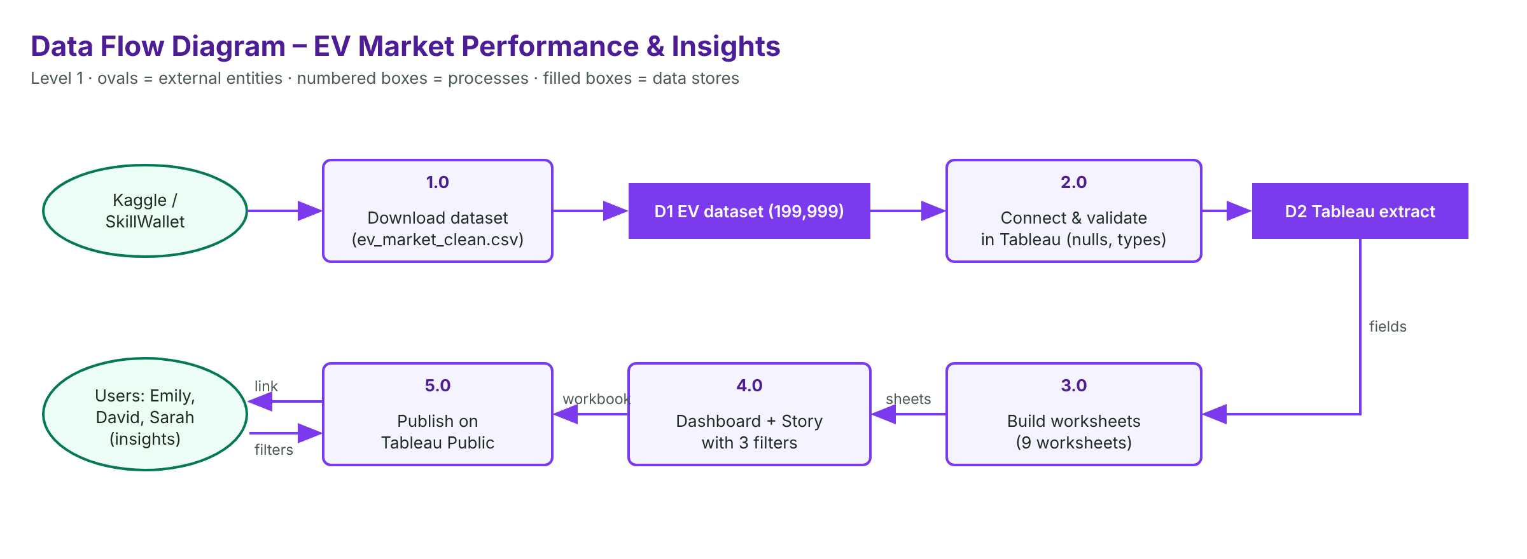

User Stories
Use the below template to list all the user stories for the product.
User Type | Functional Requirement (Epic) | User Story Number | User Story / Task | Acceptance criteria | Priority | Release
Strategy Director (Emily) | KPIs | USN-1 | As a strategy director, I can see the headline EV specifications. | 6 KPIs shown and filterable | High | Sprint-2
 | Use Case | USN-2 | As a strategy director, I can see which use cases sell the most. | Sorted bar chart | High | Sprint-2
 | Price | USN-3 | As a strategy director, I can compare average price by category. | Sorted bar chart | High | Sprint-2
 | Performance | USN-4 | As a strategy director, I can compare top speed and acceleration. | Scatter by category | Medium | Sprint-3
BI Manager (David) | Countries | USN-5 | As a BI manager, I can compare sales by manufacturing country. | Sorted bar chart of 10 countries | High | Sprint-2
 | Drivetrain | USN-6 | As a BI manager, I can see the drivetrain mix in each category. | Stacked bar AWD/FWD/RWD | Medium | Sprint-3
Researcher (Sarah) | Ratings | USN-7 | As a researcher, I can compare customer ratings by battery type. | Bar chart by chemistry | High | Sprint-2
 | Autonomy | USN-8 | As a researcher, I can see how common each autonomy level is. | Pie chart Levels 0–5 | Medium | Sprint-3
 | Range | USN-9 | As a researcher, I can see the range trend by drivetrain. | Line chart by model year | Medium | Sprint-3
 | Story | USN-10 | As a researcher, I can follow a story of the main findings. | 3-point story published | Medium | Sprint-3
All users | Filters | USN-11 | As a user, I can filter by country, drivetrain and use case. | All sheets respond | High | Sprint-3
Analyst (Developer) | Publishing | USN-12 | As an analyst, I can publish the dashboard and story online. | Public links work | High | Sprint-4

